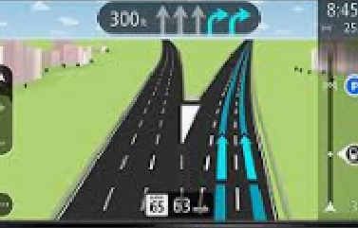

GPS BASED PROJECT TITLES

sl no | TITTLE
STG001 | OFFLINE MONITORING OF ADVERTISEMENT WORDINGS USING GSM AND GPS WITH LASER SECURITY SYSTEM
STG002 | GPS MAP USING REAL GPS RECEIVER WITH LICENSE FOR DEFENSE
STG003 | SOLDIER TRACKING SYSTEM USING GPS AND GSM MODEM
STG004 | GSM BASED ON LINE TOLL FEE PAYMENT SYSTEM
STG005 | ON LINE VEHICLE ACCIDENT REPORTER (GSM AND GPS)
STG006 | GPS BASED STATION ANNOUNCEMENT SYSTEM FOR RAILWAY NETWORKS GPS BASED ON-LINE VEHICLE TRACKING SYSTEM
STG007 | ANTI-COLLISION SYSTEM IN RAILWAY USING GSM AND GPS
STG008 | WEB BASED VEHICLE REMOTE CONTROL USING GSM/GPRS I.E..VERY ADVANCED SYSTEM FOR DEVELOPMENT USING MICRO CONTROLLER AND GPRS TECHNOLOGY.
STG009 | ACCIDENT IDENTIFICATION USING GPS AND SEND SMS THROUGH GSM TO A MOBILE
STG010 | LIVE HUMAN DETECTION AND TRACKING USING GPS AND SEND SMS THROUGH GSM TO A MOBILE

